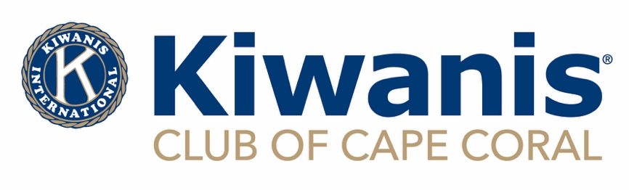

**Kiwanis is a global organization of volunteers improving the world one child and one community at a time.**

***GRANT APPLICATION***

***SUBMIT APPLICATIONS BETWEEN MAY 31 AND JULY 31, 2025***

**Amount Requested:**

**Name of the Project/Program/Event:**

**Name of Organization:**

**Website of Organization:**

**Social Media Platforms:**

**Mailing Address:**

**Physical Address: (If different from mailing address)**

**Telephone Number:**

**What is your organization’s mission statement? OR provide a link to your webpage with this information**

**Is your organization designated as Tax Exempt Under 501(c)(3)?**

**Is your organization a subsidiary of another organization? If so, please provide the name of the parent company.**

**What constituency will be served by this program or project?**

**What percentage of your constituency will be Cape Coral residents?**

**Program Summary (not to exceed 250 words which is one page of typing with double spaced lines):**

**Provide a brief overview of the project, how it will be implemented and the total cost:**

**What are the primary objectives or goals of the program or project associated with this grant?**

**Is this a new or ongoing project?**

**Outline the project/program timeline:**

**How will you evaluate the success of the program/project?**

**If ongoing, briefly provide a summary of the program/project’s success.**

**What is the plan for future funding of the program/project? What is the plan for funding if Kiwanis does not approve this grant?**

**Cape Coral Kiwanis is not well known for all the good we do. How will you promote our organization and increase community awareness with your supporters?**

**Printed name of Authorized Representative:**

**Position/Job Title:**

**Email:**

**Phone:**

**_______________________________________ ________________**

**Signature date**

**EMAIL YOUR COMPLETE APPLICATION WITH (IF YOU ARE A SCHOOL, ONLY THE APPLICATION IS REQUIRED):**

**1)THE IRS LETTER OF DETERMINATION**

**2) YOUR ORGANIZATIONS LATEST 990**

**3) FDACS CERTIFICATE**

**4) LIABILITY INSURANCE CERTIFICATE**

**TO:** [**grants@capecoralkiwanis.org**](mailto:grants@capecoralkiwanis.org) **on or before July 31, 2025**