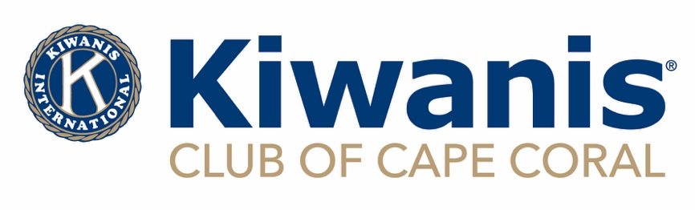

**Kiwanis is a global organization of volunteers improving the world one child and one community at a time.**

***GRANT INSTRUCTION LETTER***

***SUBMIT APPLICATIONS ON OR BEFORE JULY 31, 2025***

**The Kiwanis Club of Cape Coral supports children and our community by providing grants to organizations in Lee County through the Kiwanis Foundation of Cape Coral, our 501(c)(3) tax exempt organization.**

**Grants to Service-Leadership programs, events, and projects involving children will receive priority in funding. The following types of organizations are eligible:**

**Non-profit organizations with IRS 501(c)(3) tax exempt status**

**Schools**

**Grant requests are to be submitted online to: grants@capecoralkiwanis.org on or before the due date July 31, 2025, using the application filled in completely and with the required documentation. An acknowledgement of receipt will be sent to the contact email listed on the grant request. Grant awards are determined by the Grant Committee in August and then forwarded to the Budget Committee.  They are then approved or changed or denied by the board in October.  All requesters will be notified of their award status. Grant funds are not given out prior to October.**

**Awardees should be able to send a report of funds used and a program evaluation upon completion of the project/program.**

**This is what you will need for the application (if your organization is not a school):**

1. **IRS Letter of Determination**
2. **A 990 form for the last tax year**
3. **The FDACS Certificate**
4. **Liability Insurance Certificate**

**If this grant is for an event:**

1. **A copy of the flyer for the event**