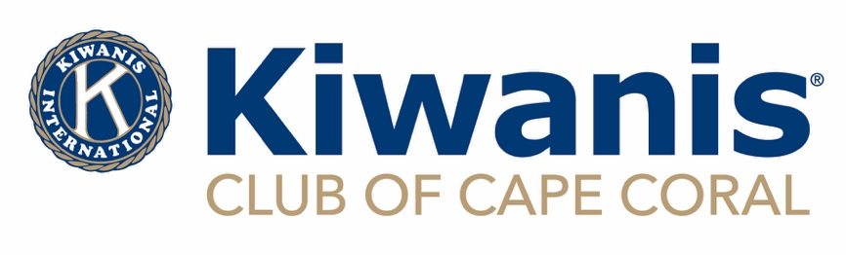

GRANT APPLICATION FOR EVENTS

OPEN DATE JUNE 1, 2024 CLOSE DATE FOR SUBMISSIONS

JULY 31, 2024 AT 11:59PM

Kiwanis is a global organization of volunteers improving the world one child and one community at a time.

Amount Requested:

Name and Date of Event:

Name of Organization:

Website of Organization:

Social Media Platforms:

Mailing and Physical Address:

Telephone Number:

What is your organization’s mission statement? OR provide a link to your webpage with this information

Is your organization designated as Tax Exempt Under 501(c)?

Is your organization a subsidiary of another organization? If so, please provide the name of the parent company.

What constituency will be served by this event?

What percentage of your constituency will be Cape Coral residents?

What are the primary objectives or goals of the event associated with this grant?

Is this a new or ongoing event?

How will you evaluate the success of the event?

If ongoing, briefly provide a summary of the event’s success.

What is the plan for future funding of the event? What is the plan for funding if Kiwanis does not approve this grant?

Printed name of Authorized Representative:

Position/Job Title:

Email:

Phone:

_______________________________________ ________________

Signature date

EMAIL YOUR COMPLETE APPLICATION WITH (IF YOU ARE A SCHOOL, ONLY THE APPLICATION IS REQUIRED):

1)THE IRS LETTER OF DETERMINATION

2) YOUR ORGANIZATIONS LATEST 990

3) FDACS CERTIFICATE

4) LIABILITY INSURANCE CERTIFICATE

5) EVENT FLYER

TO: [grants@capecoralkiwanis.org](mailto:grants@capecoralkiwanis.org) on or before July 31, 2024