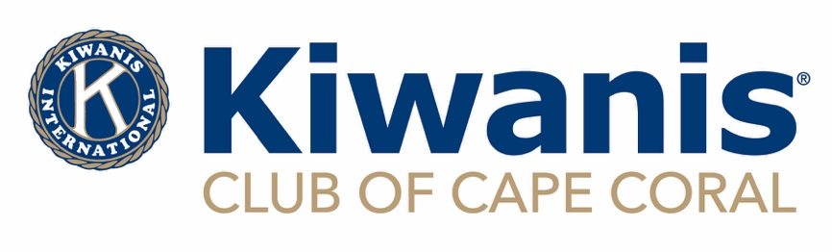

GRANT APPLICATION FOR PROGRAMS OR PROJECTS

OPEN DATE JUNE 1, 2024 CLOSE DATE FOR SUBMISSIONS

JULY 31, 2024 AT 11:59PM

Kiwanis is a global organization of volunteers improving the world one child and one community at a time.

Amount Requested:

Name of the Project/Program:

Name of Organization:

Website of Organization:

Social Media Platforms:

Mailing and Physical Address:

Telephone Number:

What is your organization’s mission statement? OR provide a link to your webpage with this information

Is your organization designated as Tax Exempt Under 501(c)(3)?

Is your organization a subsidiary of another organization? If so, please provide the name of the parent company.

What constituency will be served by this program or project?

What percentage of your constituency will be Cape Coral residents?

Program Summary (not to exceed 250 words which is one page of typing with double spaced lines):

Provide a brief overview of the project, how it will be implemented and the total cost:

What are the primary objectives or goals of the program or project associated with this grant?

Is this a new or ongoing project?

Outline the project/program timeline:

How will you evaluate the success of the program/project?

If ongoing, briefly provide a summary of the program/project’s success.

What is the plan for future funding of the program/project? What is the plan for funding if Kiwanis does not approve this grant?

Printed name of Authorized Representative:

Position/Job Title:

Email:

Phone:

_______________________________________ ________________

Signature date

EMAIL YOUR COMPLETE APPLICATION WITH (IF YOU ARE A SCHOOL, ONLY THE APPLICATION IS REQUIRED):

1)THE IRS LETTER OF DETERMINATION

2) YOUR ORGANIZATIONS LATEST 990

3) FDACS CERTIFICATE

4) LIABILITY INSURANCE CERTIFICATE

TO: [grants@capecoralkiwanis.org](mailto:grants@capecoralkiwanis.org) on or before July 31, 2024